Make sure you have Python and NodeJS installed before processing to the next step. If not, you can download it here:

[Download Python | Python.org](https://www.python.org/downloads/)

[Download | Node.js (nodejs.org)](https://nodejs.org/en/download/)

After cloning the project to your local device, you should see job-portal folder.

Double click to open job-portal folder, right-click and choose Open with Code. If you don’t have this option, you can simply copy the directory and open it inside VScode.

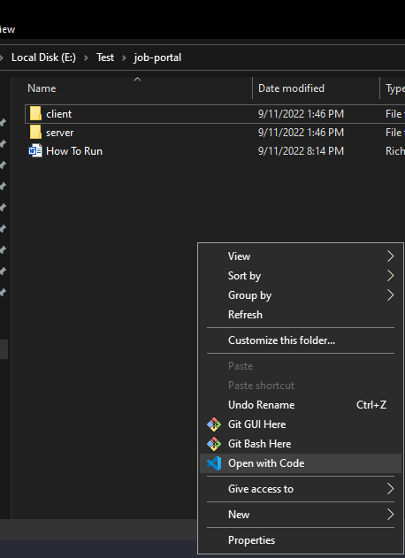

1. Get the React server running
   1. In VScode, open terminal. (I use **Git Bash** as my default Terminal)

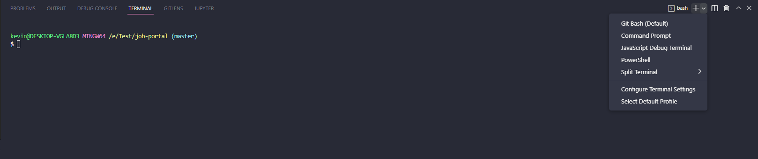

* 1. Type **“cd client”** to go to client directory, then **“npm install”** to install all modules and dependencies listed on package.json file. (This may take a while)
  2. Type **“npm start”** to start the React server. It will automatically render the front-end on your default browser.

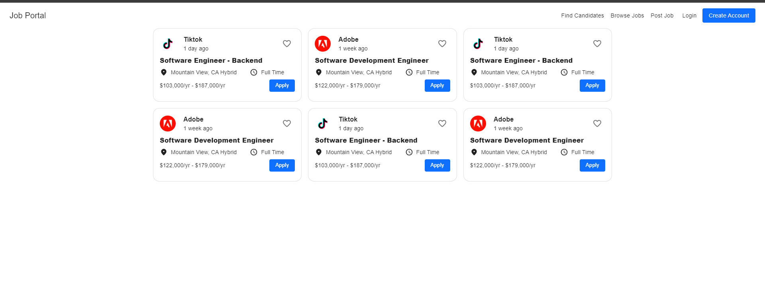

1. Get the Flask server running
   1. Open another bash terminal by clicking the down arrow next to the plus sign and select **Git Bash**

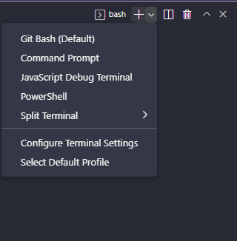

* 1. You can also split terminal for easier observation:

Under Terminal, select Split Terminal or use the shortcut Ctrl + Shift + 5

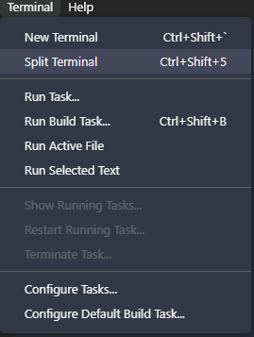

* 1. It should look like this

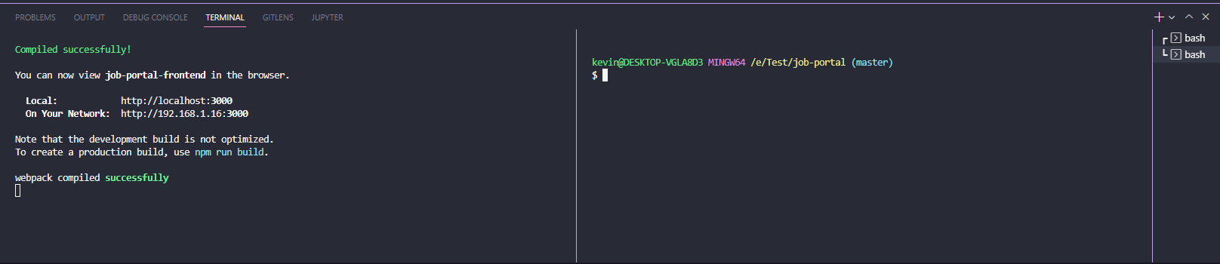

* 1. Type **“cd server”** to go inside the server folder.
  2. Type **“python -m venv venv”** to create a virtual environment for your python code. Select **Yes** if VScode asks you to change your interpreter.

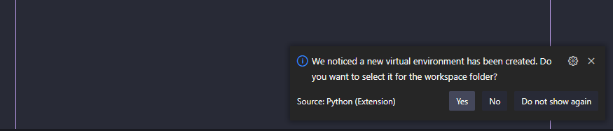

* 1. Type **“source venv/Scripts/activate”** to activate your virtual environment. The (venv) indicates you have activated your virtual environment.

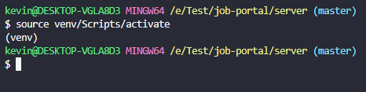

* 1. Next, **“cd code”** to go into the code folder.
  2. Type **“pip install -r requirements.txt”** to install all the libraries that we are going to use for our back-end.
  3. Type **“touch .env”** to create the environment variables. This file holds all the sensitive information of our server. (Note: You can manually create this file using VScode).
  4. Open the .env file and set the secret key of your choice. Remember to click Save.

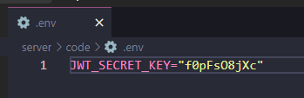

* 1. Now, we can run out back end server by typing **“python app.py”**